

Mantis Work Instruction
QA-0002
Revision A

Revision History
Rev | Status | Date | Author | CO # | Description
A | Draft | 5/04/05 | SLB | TBD | Initial Release
A | Draft | 5/13/05 | SLB | TBD | Added new custom fields per comments from S.Sadedin and S.Doyle.
A | Draft | 11/5/08 | SLB | TBD | Renamed document from Q-0027 to QA-0002.
B | Draft | 12/22/09 | SLB | TBD | Final edits.

Training
Role | New | Trained in previous rev.
Quality Manager | Instructor-led | Not applicable for Rev A
Engineering | Instructor-led | Not applicable for Rev A
QA | Instructor-led | Not applicable for Rev A

Purpose
The MedCommons software development process requires that changes follow a controlled and documented procedure. To track change requests, MedCommons uses the application Mantis, a database that stores all defect reports and enhancement requests and is accessed by a web front-end. Since Mantis is also the chosen mechanism for capturing corrective and preventive actions, special attention may be given to issues flagged as CAPAs.

Scope
This work instruction details the process for using Mantis to request and implement changes to software, including defect and enhancement requests. See Q-0016 Product CAPA for specifics on how CAPAs are handled.

Responsibilities
QA (and others)
All MedCommons personnel may report problems with the software and requests for enhancements by entering them into the Mantis system. Quality Assurance personnel typically verify bug fixes and close issues.
Engineering
Engineering personnel read the issues that are assigned to them, fix the problems reported, and add details about problem resolution.
Quality Manager
The Quality Manager oversees the Mantis system to ensure that issues are being reported and moved along in a timely manner. Reports may be requested at any time. The Quality Manager also sifts through all entries in Mantis in order to determine whether specific issues or trends warrant being flagged as CAPAs.

Referenced Documents
Q-0016 Product CAPA
Q-0023 Product Software Verification and Validation

Procedure

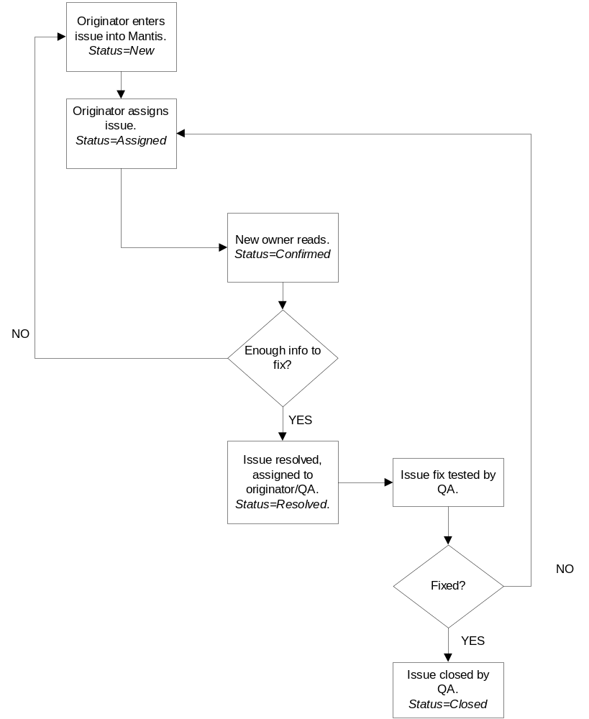

Step | Description
Originator enters issue into Mantis. Status=New | New bug or enhancement request entered into Mantis under the correct project heading. When an issue is first filed, it lists as New.
Issue Assigned.  Status=Assigned | The issue is assigned to someone to address it. This can be done in one step when using the Advanced view. But when the Simple view is used, an additional step of opening (updating) the issue is required to access this field.
New owner reads. Status=Confirmed | The new owner of the issue (usually someone in Engineering) should read the entry and update it by marking the status Confirmed. This just says that it’s been read and acknowledged.
Enough info to fix? | The owner makes a decision as to whether there is enough information to move on to a fix. If so, he continues. If not, he may request additional information from the originator. He may also set the status back to Assigned and kick it back to the originator, adding a note to the entry.
Issue resolved, assigned to originator/QA. Status=Resolved. | Once the problem is fixed, its status is set to Resolved and the new owner is set to whoever must verify the resolution. This is typically the originator or someone in QA.
Issue fix tested. | The new owner reads all of the information now in the report. If regression testing is required, he carries it out and updates the bug.
Fixed? | Decision point: is the problem resolved or not? Is the resolution satisfactory?
Status=Closed. | If the problem is resolved satisfactorily, the issue’s status is set to Closed. Adding the number of the build tested against is a highly desirable thing. If the problem is not resolved, it is re-assigned to the person responsible for the resolution and a note is added to the detail about why it’s not satisfactory.  The issue may also be deferred to another release. At present, there is no way to mark a status as deferred, so the issue is moved to a new project.

Deferring Issues
At any time, a decision may be made to defer a bug or enhancement request to a later release. This is a typical course of action with enhancement requests, but also occurs with bugs that are not slated for inclusion in the current release. A note should be added to the issue to clarify the move. Select the appropriate project from drop-down at the top right of the Mantis screen, and click the Switch button.
Entering New Defects/Enhancements
All issues shall be entered into the Mantis database under the appropriate project name. New issues can be entered by any member of Engineering, QA or Support. The following fields should be filled in (where * denotes required field):

Field | Value to be entered
Category | List of components of the software. Select the component where the bug is located.
Reproducibility | Select the option that best applies. How readily is the bug reproduced?
Severity | Select which applies. How serious is this problem? Most will probably be marked Minor.
Priority | How urgent is the fix for this? Most should be marked Normal.
*Summary | Enter a brief summary of the problem.
*Description | Add any known details about the problem.
Additional information | Field where people add notes as they work on the problem. Often contains steps to reproduce (as it shows up on both forms).
CAPA | Checkbox checked only if instructed to because issue is marked for a “corrective and preventive action”.
Issue Type | Select whether the issue is a bug, an enhancement request, or a documentation issue
Requirement | Enter the requirement number for the issue, if it exists. If this is an enhancement request, it is important to enter this!
Upload file | (browse…) Attach any supporting files that help with the issue. Screen shots, data files, test files…
View status | Check Public box. Private won’t allow others to see it.
Report stay | Check the box to report more issues.

Clicking on the Advanced Report link will take you to a longer form with more fields.

Field | Value to be entered
Category | List of components of the software. Select the component where the bug is located.
Reproducibility | Select the option that best applies. How readily is the bug reproduced?
Severity | Select which applies. How serious is this problem? Most will probably be marked Minor.
Priority | How urgent is the fix for this? Most should be marked Normal.
Select Profile | Select from list of machine profiles already on file.
Fill in:  Platform  OS  OS Version | Enter information relevant to the system on which the bug was found.
Product Build | Enter SVN build number
Assign to | Select name of employee to whom the bug should be assigned. Update with each status change.
*Summary | Enter a brief summary of the problem.
*Description | Add any known details about the problem.
Steps to Reproduce | Enter all steps to reproduce the problem in sequential order.
Additional information | Any additional information that will help to resolve the problem will go here.
CAPA | Checkbox checked only if instructed to because issue is marked for a “corrective and preventive action”.
Issue Type | Select whether the issue is a bug, an enhancement request, or a documentation issue
Requirement | Enter the requirement number for the issue, if it exists. If this is an enhancement request, it is important to enter this!
Upload file | (Browse…) Attach any supporting files that help with the issue. Screen shots, data files, test files…
View status | Check Public box. Private won’t allow others to see it.
Report stay | Check the box to report more issues.

Additional fields found on Update>>Advanced page

Projection | Guesstimate as to the effort needed to fix the problem. Ranges from Tweak to Redesign.
ETA | Estimated time it will take to fix the problem. Ranges from less than one day to more than one month.
Resolution | How was the issue resolved?
Add Note | As people work on the problem, they add notes here about what they are finding.

